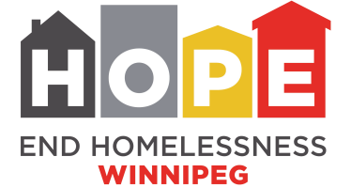
Membership Application Form
It’s easy to become an End Homelessness Winnipeg member organization. Membership is open to organizations in all sectors that support End Homelessness Winnipeg’s aims and objectives as described below and on the following page. Applying is easy. Just complete this form and send it to us by mail or email. Our Board of Directors will consider your application at its next meeting.
As a member, your organization will receive a notice of annual and special meetings of members and, if represented at these meetings, will be entitled to one vote.
Organization name
Sector | ❏ Community/non-profit ❏ Business/private ❏ Government/public
 | ❏ Other (please specify)
Address
 | Unit, street, city, postal code
The following positions/people are authorized to receive notices and vote on behalf of our organization at annual meetings and special meetings of members.
1. Position title |  | Name of person currently in the position |  | Phone/email
2. Position title |  | Name of person currently in the position |  | Phone/email

Membership pledge
Our organization supports End Homelessness Winnipeg’s aims and objectives.
- We believe that it is our community’s responsibility – from government to corporate to community-based organizations to those who have been or are now homeless – to prevent and end homelessness.
- We will work together to build a movement among all sectors to end homelessness, in good faith, openness and trust.
- We support End Homelessness Winnipeg as the backbone organization leading and coordinating the multi-sectoral effort required to end homelessness in Winnipeg and its guiding statements and role as presented on the following page.

Signature of authorized signing officer | Date
Name (please print) | Position title | Phone/email
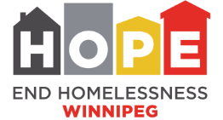

End Homelessness Winnipeg: Guiding Statements and Role, 2019
Mission | To create lasting solutions with our community that prevent and end homelessness
Vision | A community where everyone has a home and the supports they need to belong
Values that guide our work | We value  - The UN’s declaration that housing is a human right  - The UN’s Declaration on the Rights of Indigenous Peoples  - Truth and reconciliation as a path to ending Indigenous homelessness  - Social inclusion and working to end all forms of discrimination and racism  - The voice of people with lived experience of homelessness  - People, organizations, and sectors working together around a common vision and shared goals  - Integrity, accountability and transparency in all that we do
Role | - Influence policy: Influence the design and implementation of policies and services to end homelessness
 | - Connect strategies: Connect funding, services, and other resources and align plans to end homelessness
 | - Strengthen the sector: Develop the capacity of individuals, professionals, and organizations to address homelessness as a coordinated sector
 | - Enhance resources: Secure and develop resources (e.g., funding, data, metrics, research, training, tools and frameworks) to increase knowledge and understanding, inform decisions, and drive action

End Homelessness Winnipeg is an Indigenous organization: 75% of the directors elected to our Board must be of Indigenous descent and our target is for 75% of staff to also identify as being Indigenous.

